

INTRODUCTION TO COMPUTING

GROUP7

ASSIGNMENT

|  |  |
| --- | --- |
| NAME & SURNAME | STUDENT NUMBER |
| SHWELE PHULU | 221102132 |
| KING HIHOLIKE | 221028080 |
| DENARD ANDREAS | 221067817 |
| ELINA LINOO PETRUS | 220028796 |
| CHRIS N.MUKADI | 217118151 |

MODULES

This keeps track of all customer details, and, makes sure the customer data is stored into the database.

Customers login ()

1. Customer _ID

2. Customer account

3. Pending orders

Staff login () total hours worked

This enables the business to supervise its staff, and make sure they are all doing that they are supposed to do.

1. Staff_ ID

2. Staff status

Services Calculate change (), Services details ()

Makes sure the right services are provided to the customer and clients.

1. Service name

2. Cost

3. Booking delete ()

Product Availability () Calculate change () Product status ()

1. Product_ ID

Makes sure the business does not run out of products, and gives inside on the product cost.

2. Product Status

3. Product Availability

4. Cost

Shipment tracking () & date ()

1. Order_ ID

Monitors the customer orders, their location and makes sure they are diliverd on time.

2. Date of Arrival

3. Comment

FUCTIONS

SHIPMENT

tracking(order_ ID) {

displays the order_ ID

}

date(order_ ID) {

display date of arrival

}

PRODUCT

productStatus(product ID) {

display product ID

}

availability(product ID)}

sum=productonshelf – productpurchased

return sum

}

calculateChange(cost,amount paid) {

Sum=amount paid-cost

Return sum

}

add(booking){

add booking

display booking

}

delete(booking){

delete booking

display “booking deleted”

}

SERVICES

serviceStatus(service name) {

dispalyservice status

}

PSEURDOCODE

Start

go onto the website

login into the website

display customer account

browse for the service available

select service of choice

receive digital receipt

book for service

END

Start

Selectproduct name

display product status

Pay for product

Pay shipment fee

receive invoice

END

availability(product ID)[

Sum=product on shelf-product purchased

Return sum

]

Calculate charge(cost, amount, paid) [

Sum=amount paid-cost

Return sum

]

Start

Enterlocation(address)after purchasing

Product or service

Pay shipment fee

Receive invoice

END

trackOder(order_ID)[

display order_ID

]

date(order_ID)

display date of arrival

]

FLOWCHARTS

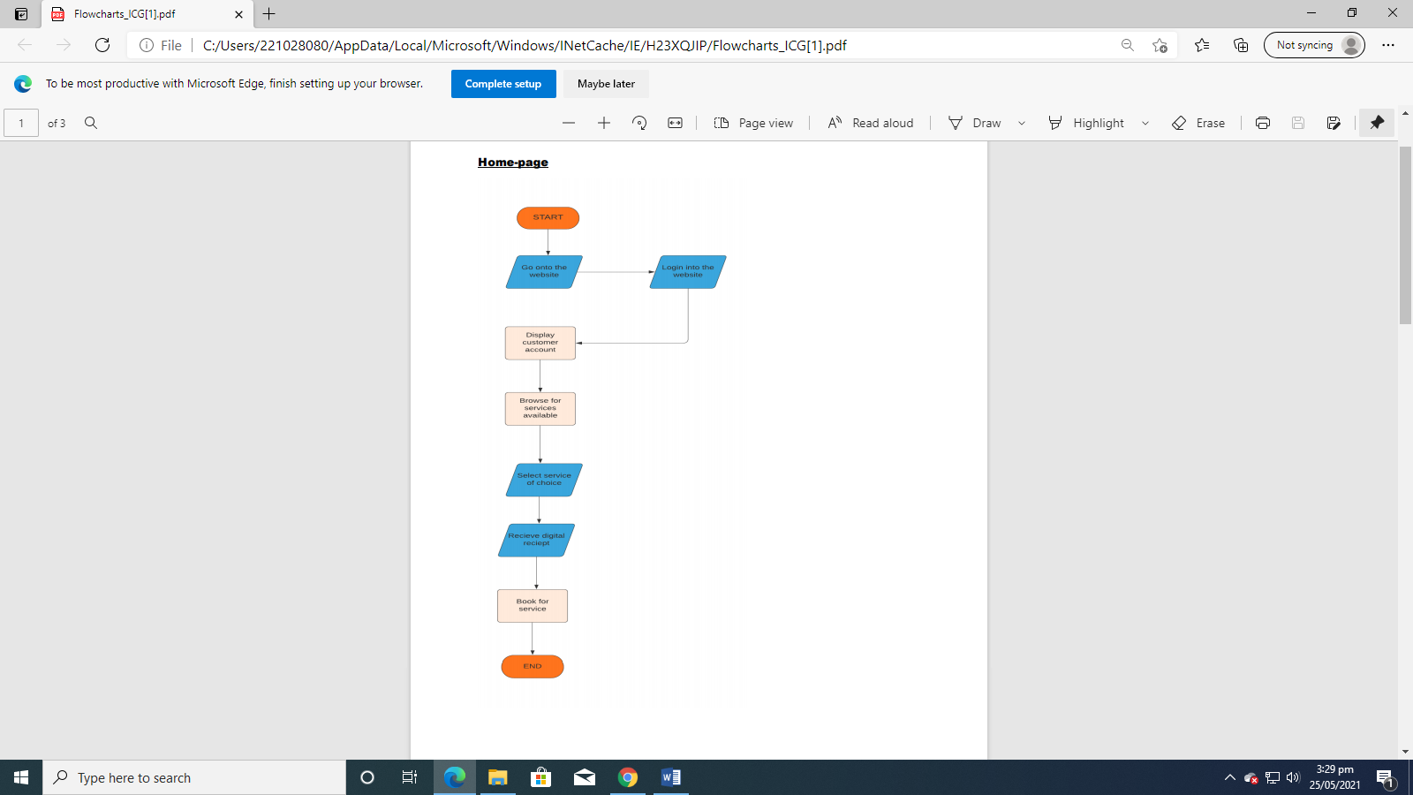

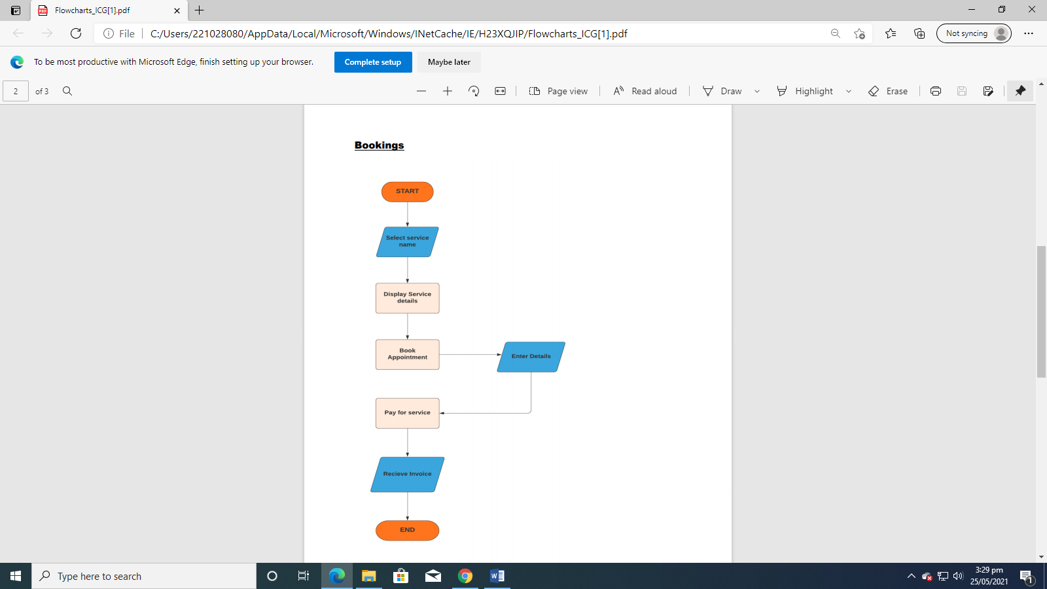

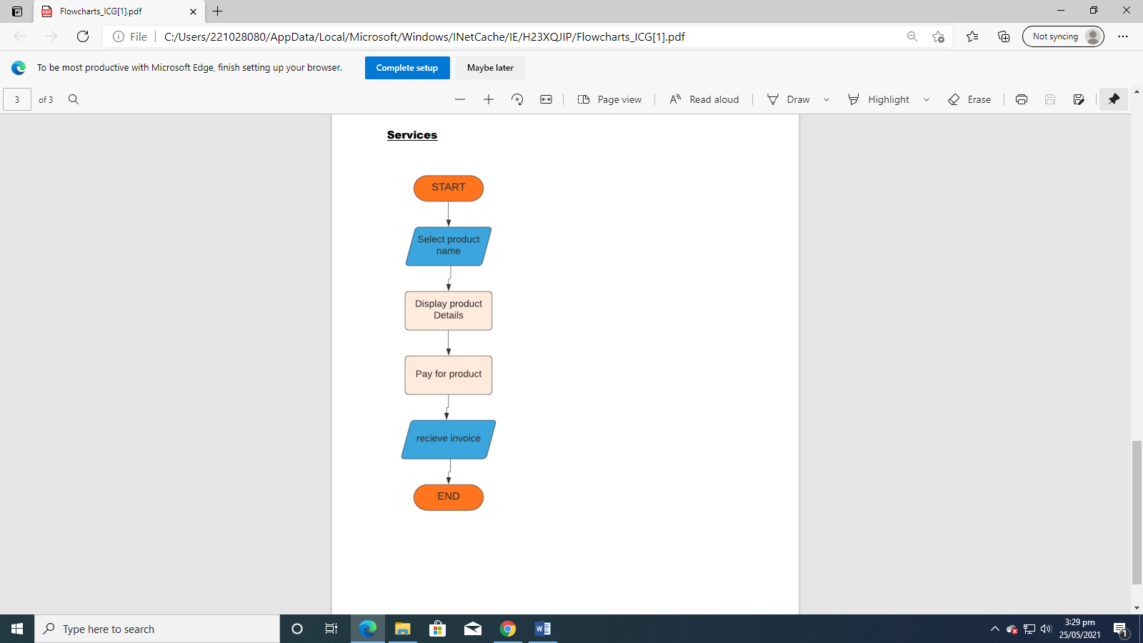

DATABASE

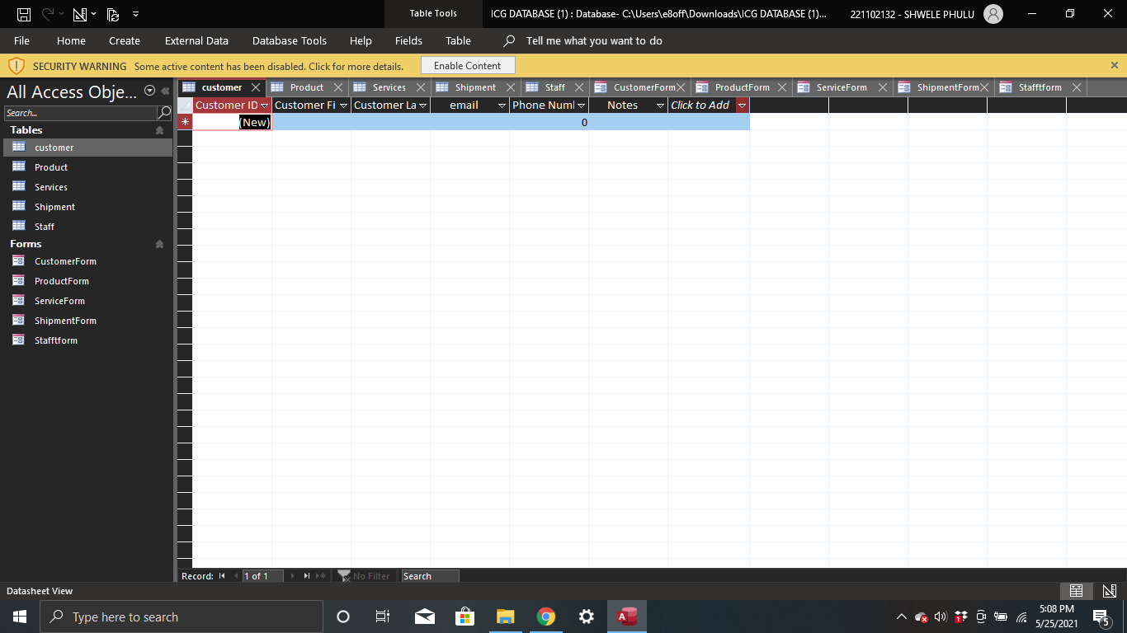

Keeps records of all the staff status, customer status, shipments, and orders.

Names, company names, account numbers, Social Security numbers and client numbers are examples of identifying information that a business can store in a database. Businesses can also use databases to store financial information like credit card numbers and bank account numbers.

SCRATCH PROJECT













[](MviaVideo1622017058870.mp4)